**Functional Document**

|  |  |
| --- | --- |
| **Application** | NGERP - Centra |
| **Service Bundle** | Sales Management |
| **Service Request** | Print Batch DO |

**Description :**

Print Batch Do is Used to print physical Invoice for Delivery Order (DO). The list of delivery order which are completed will be loaded in this Form. User can filter the Deliver order based on Date, Customer Program and Customer Channel.

**Workflow Process :**

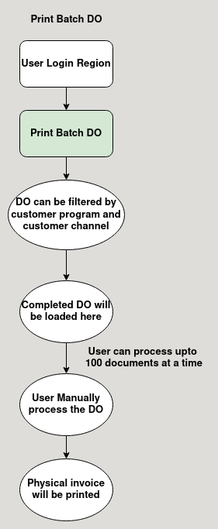

**Business Rules :**

* Print Batch Do can be accessed only in Region.
* The Document Status of DO should be completed to generate invoice for that DO.
* User can able to Filter DO like the following:
  + Date
  + Customer Program
  + Customer Channel
* Document type which are loaded in the form are:
  + Promotion Order
  + Topline - Register Promotion Order
  + Topline - Non-Registered Promotion Order
  + SG&A Register Promotion Order
  + SG&A Non-Registered Promotion Order
* Print Batch Do is Used to print physical Invoice for Delivery Order (DO).
* The Do will be printed in a printer linked to the computer after processing the Delivery Order.